Access of the audit progress is available to providers. The provider will only have access to audits associated with that provider. Providers will be given their username and password with the medical record request letter.

Login at this website: https://hppac.mpro.org/

Enter the username and password provided with audit request.

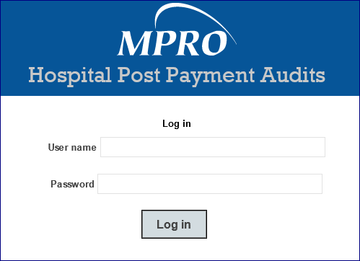

The opening screen is a listing of the audits with the user Provider NPI.

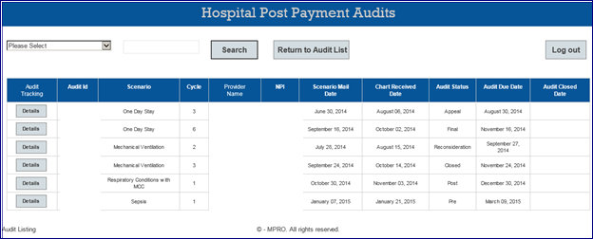

For further details, click on the ‘Details’ button to the left of the desired Audit ID

If you have any questions, please contact:

Toria Spencer, administrative assistant
Phone: 248-465-7368
Fax: 248-465-7303
tspencer@mpro.org

